Administrator Agreement Form
New teachers entering any discipline in the public schools of Texas face many challenges. Classroom management, managing relationships with students, parents, and administrators, balancing home and work life, and simply adjusting to the demands of a career after spending many years as a student, all contribute to the stress a new teacher faces.
A beginning agriculture teacher has all of the preceding issues to deal with, as well as managing a sometimes overwhelming FFA program, complete with livestock show and project center responsibilities, possibly dealing with a booster club, to go along with many competitive leadership and judging activities.
As a result of all the factors just mentioned, and a growing demand for agriculture teachers, it is becoming increasingly difficult to locate highly effective young teachers to replace those leaving the profession. Many young teachers leave the profession discouraged, burned out, and disappointed after a year or two in the classroom.
The VATAT board has selected mentors who are recently retired master agriculture teachers to work with young teachers for the 2018-2019 school year. If you approve, your agriculture teacher will be a part of this program. The mentors have been carefully selected for the honesty, integrity, and professional ethics they exhibited during their career. Each will be cleared by a criminal background check, and will be glad to meet any further requirements you might need.
The mentor will observe the mentee teaching class, facilitate a teacher/administrator meeting, and work with the mentee both in person and electronically on a variety of topics.
It should be noted that these individuals will be working with your teacher only on an advisory basis and have no implied authority to make decisions concerning your program. The purpose of this program is to support early career teachers, thereby strengthening local programs and adding value for your students. If we can keep more highly effective young teachers in the classroom, we all win.
Sincerely,
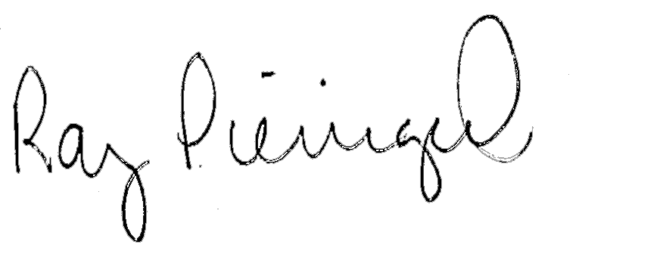
Ray Pieniazek
Executive Director, VATAT

Administrator Agreement
I _______________________________, grant approval for agriculture teacher ______________________________ to be a part of the VATAT Professional Mentor Program for the 2019-2020 school year.
Administrator Signature __________________________
Mentee Signature __________________________
Date __________________________

